Made BY :-Jadeja Mouryrajsinh
1. Introduction

This document describes the design and implementation of an E-Commerce Database System using PostgreSQL on Ubuntu Linux.
The objective of this project is to understand how real-world e-commerce platforms manage users, products, orders, and payments using relational databases and SQL.

This database allows:
- Customers to register
- Products to be stored
- Orders to be placed
- Payments to be recorded
- Sales data to be analyzed

2. Database Creation

Database Name: ecommerce_db
The database was created using PostgreSQL with the following command:
CREATE DATABASE ecommerce_db;
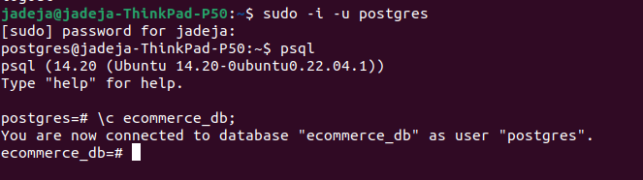
3. Table Creation

The following tables were created to store e-commerce data:
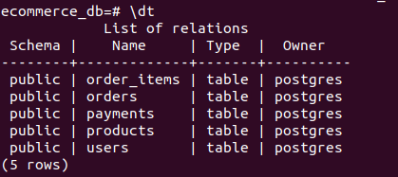

Table Name | Purpose
users | Stores customer details
products | Stores product information
orders | Stores customer orders
order_items | Stores which products are in each order
payments | Stores payment details

These tables were created using SQL with Primary Keys and Foreign Keys to ensure data integrity.

4. Data Insertion

Large realistic data was inserted into all tables:
- More than 600 users
- More than 600 products
- More than 600 orders
- More than 600 order items
- More than 600 payments
The data contains customer names and product and payment information.
Example:
INSERT INTO users (name, email, password)
VALUES ('Amit Patel','amit@gmail.com','123');
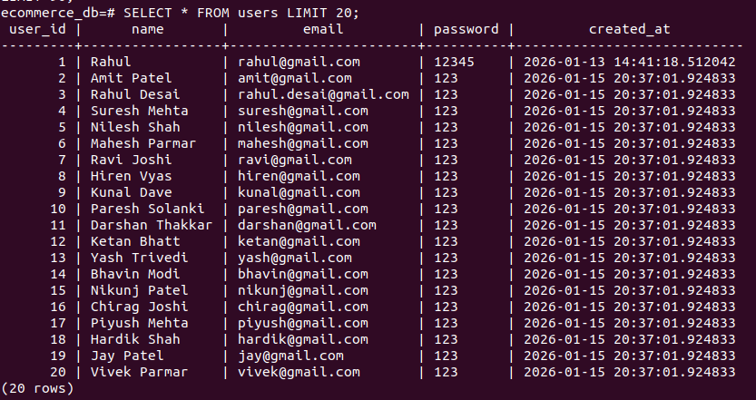
- Users Data:
- Product Data:
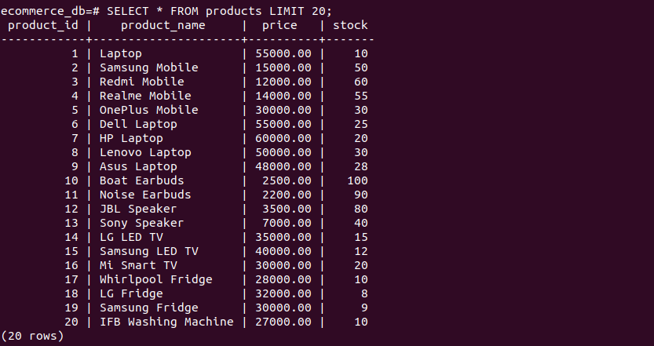
- Order Data:
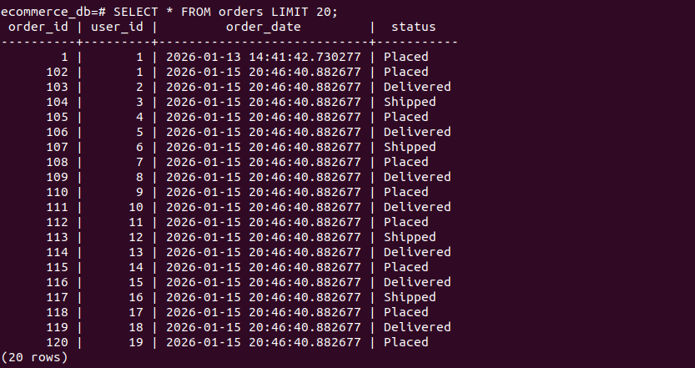

5. Fetching Records (SELECT Queries)
The following SQL queries were used to verify inserted records:
- SELECT user_id, full_name, email, phone, created_at FROM users;
- SELECT product_id, product_name, category, price, stock_quantity FROM products;
- SELECT order_id, user_id, order_date, total_amount, order_status FROM orders;
- SELECT order_item_id, order_id, product_id, quantity, price FROM order_items;
- SELECT payment_id, order_id, payment_date, payment_method, payment_status, amount FROM payments;

Explanation:-
SELECT queries were used to retrieve data from all tables for verification.
These queries ensure that records were inserted correctly into the database.

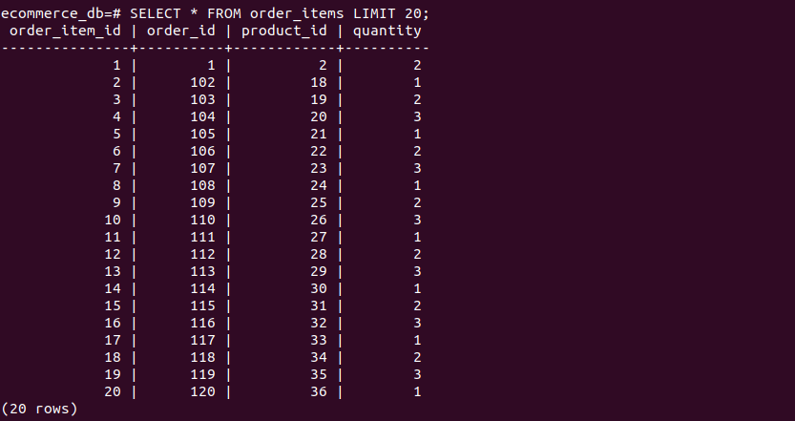
Order_item Verify:

Payments Verify:
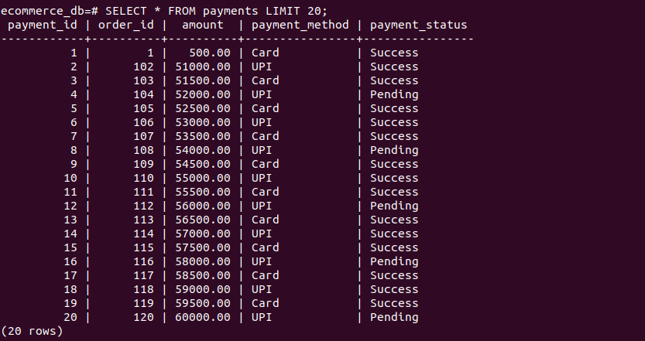

6. Table Relationships
The database follows a real-world relational model:

Relationship | Type
Users → Orders | One-to-Many
Orders → Order_Items | One-to-Many
Products → Order_Items | One-to-Many
Orders → Payments | One-to-One

This allows tracking:
- Which user placed which order
- Which products are in each order
- How much was paid

7. Performing Queries

Filtering Data (WHERE)

- SELECT user_id, full_name, email, created_at FROM users WHERE full_name LIKE '%Patel%';

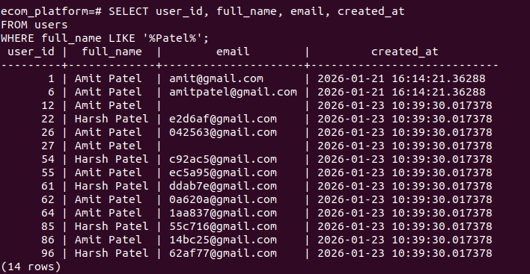

- SELECT product_id, product_name, category_id, price FROM products WHERE price > 5000;

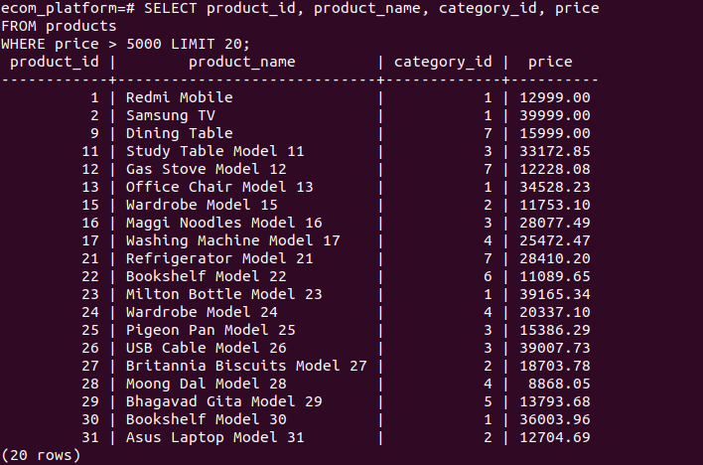

- SELECT order_id, user_id, order_date, total_amount, order_status
FROM orders WHERE user_id = 10;

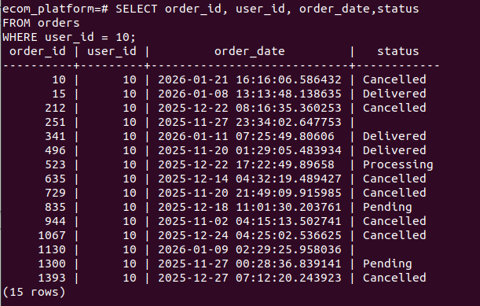

- SELECT order_item_id, order_id, product_id, quantity
FROM order_items WHERE quantity = 2 limit 20;
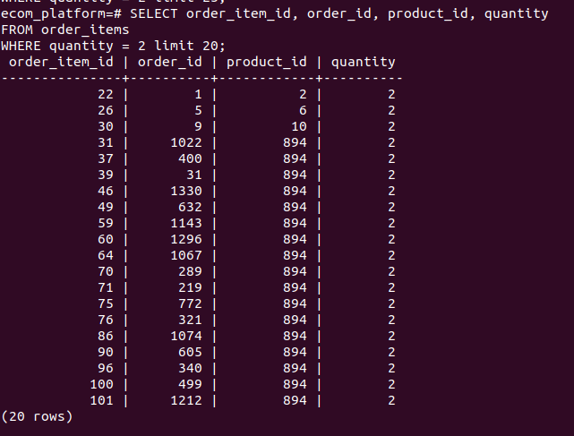

Sorting Data (ORDER BY)

Products Price High → Low
- SELECT product_id, product_name, category_id, price FROM products ORDER BY price DESC;
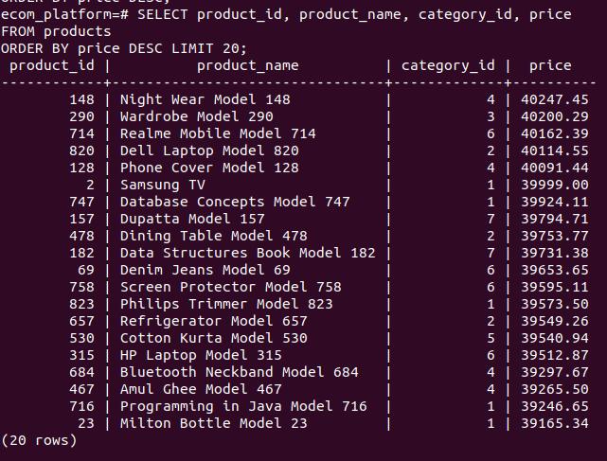

Explanatio:
- Sorts products by highest price first.
- Useful for premium product analysis

Products Price Low → High

- SELECT product_id, product_name, category_id, price FROM products ORDER BY price ASC;

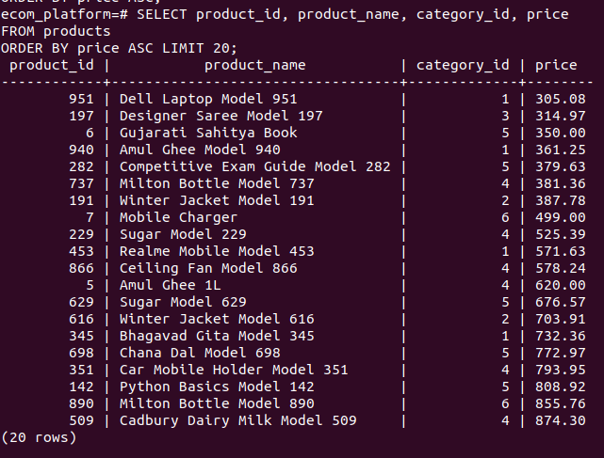

Explanatio:
- Sorts products from cheapest to most expensive.
- Helps price comparison.

Users Sorted by Name

- SELECT user_id, full_name, email, created_at FROM users ORDER BY full_name;
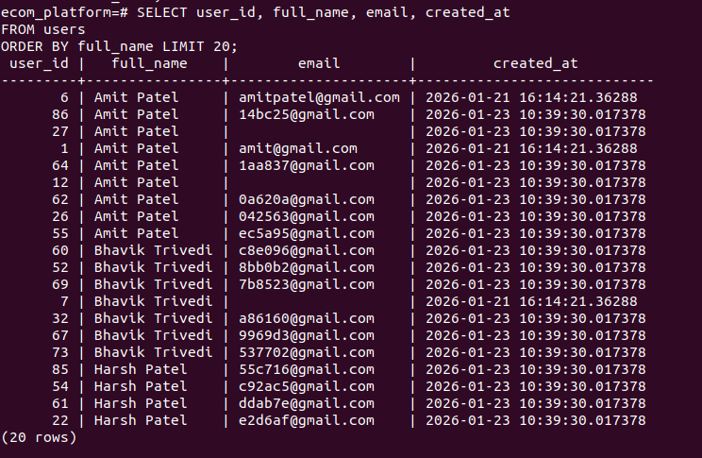

- SELECT * FROM orders ORDER BY order_date DESC;

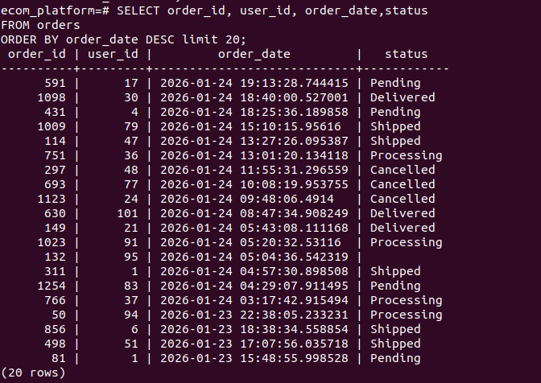

SQL Aggregate Functions

- SELECT COUNT(*) AS total_users FROM users;
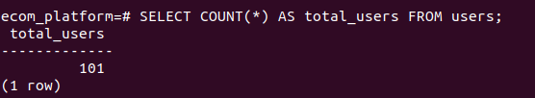

- SELECT COUNT(*) AS total_products FROM products;
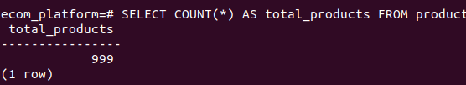

- SELECT MAX(price) AS highest_price FROM products;
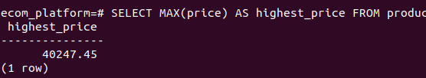

- SELECT MIN(price) AS lowest_price FROM products;
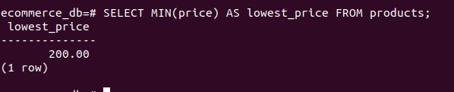

- SELECT AVG(price) AS avg_price FROM products;
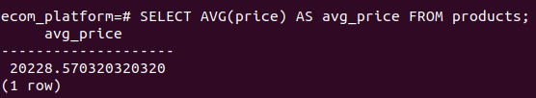

GROUP BY Queries

- SELECT user_id, COUNT(order_id) AS total_orders FROM orders GROUP BY user_id;
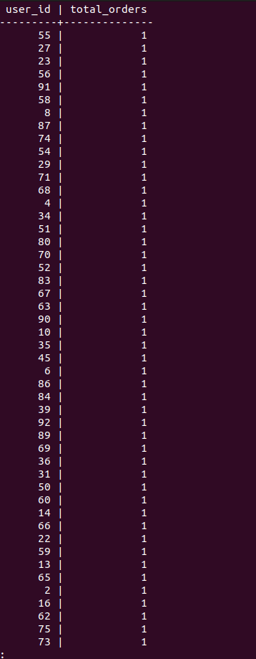

- Counts how many orders each user placed.
- Used to analyze customer activity.
- SELECT product_id, SUM(quantity) AS total_quantity FROM order_items GROUP BY product_id;
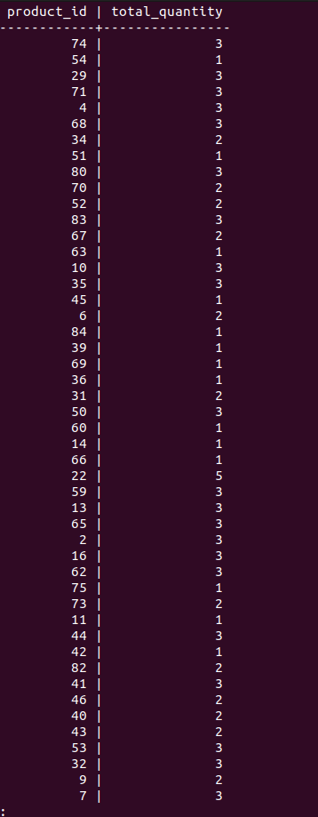

HAVING Clause

- SELECT user_id, COUNT(order_id) AS order_count FROM orders GROUP BY user_id HAVING COUNT(order_id) > 1;

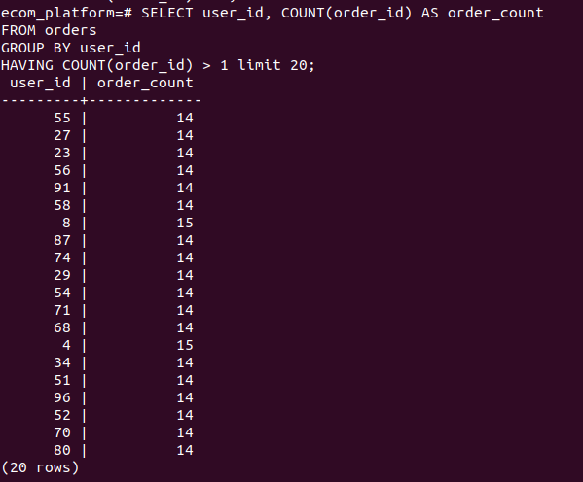

Explanation:
- Filters customers with multiple purchases.
- Used to find loyal customers.

JOIN Queries

INNER JOIN
- SELECT o.order_id, u.name, o.order_date FROM orders o INNER JOIN users u ON o.user_id = u.user_id;
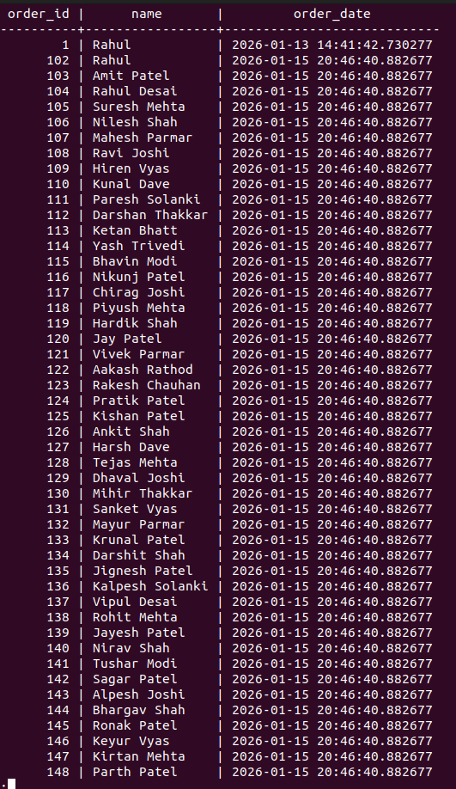

- SELECT p.product_name, oi.quantity FROM order_items oi INNER JOIN products p ON oi.product_id = p.product_id;

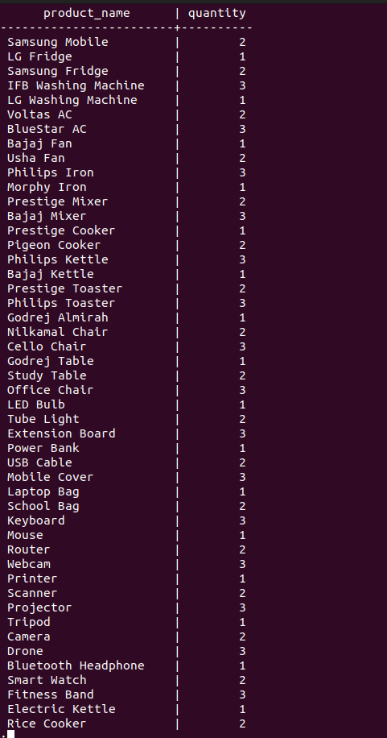

LEFT JOIN
- SELECT u.name, o.order_id FROM users u LEFT JOIN orders o ON u.user_id = o.user_id;

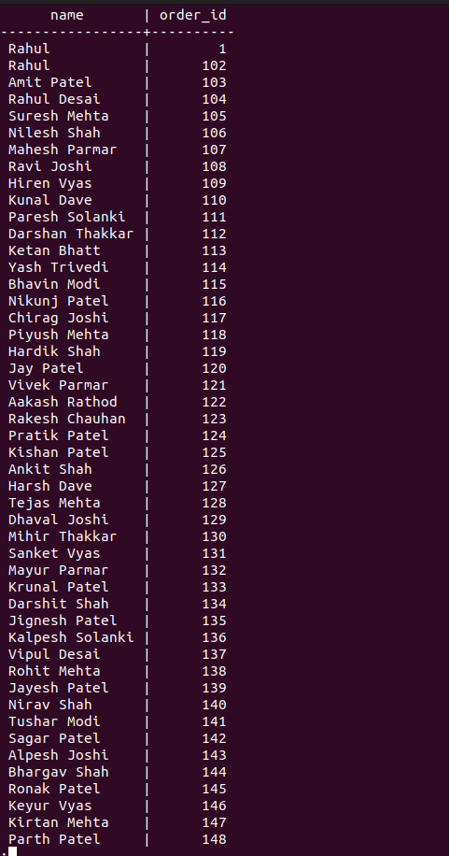

RIGHT JOIN
- SELECT u.name, o.order_id FROM users u RIGHT JOIN orders o ON u.user_id = o.user_id;
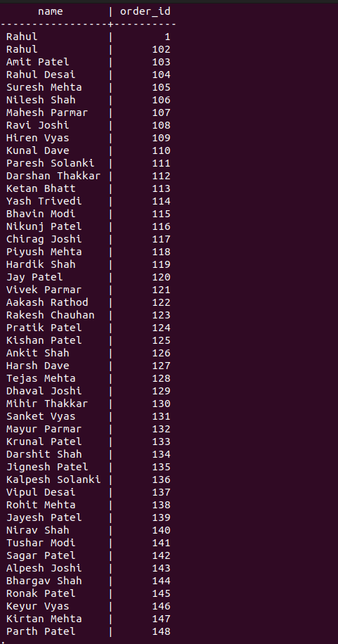

FULL JOIN
- SELECT u.name, o.order_id FROM users u FULL JOIN orders o ON u.user_id = o.user_id;

BUSINESS ANALYSIS

Top Revenue Generating Products
- SELECT p.product_id, p.product_name, SUM(oi.quantity * oi.price) AS total_revenue FROM order_items oi JOIN products p ON oi.product_id = p.product_id GROUP BY p.product_id, p.product_name ORDER BY total_revenue DESC;
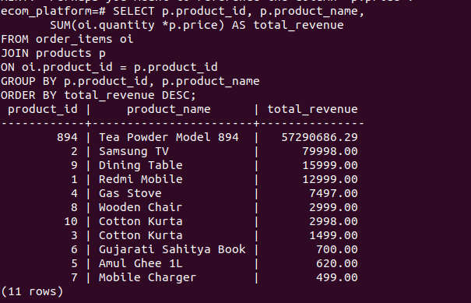

Explanation:
- This query calculates total revenue generated by each product by multiplying quantity sold with price.
- It helps identify top-performing products, useful for inventory planning, marketing, and profit optimization.

Most Valuable Customers (Spending Analysis)
- SELECT u.user_id, u.full_name,SUM(o.order_id) AS total_spent FROM orders o JOIN users u ON o.user_id = u.user_id GROUP BY u.user_id, u.full_name ORDER BY total_spent DESC;
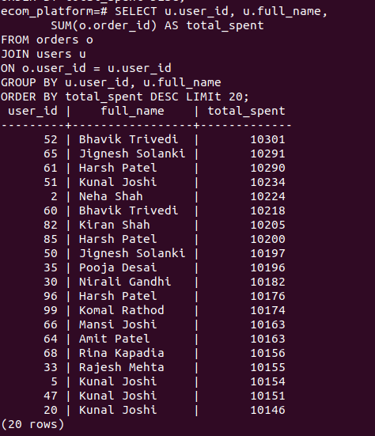

Explanation:
- This query finds customers who spent the most money on orders.
It supports customer segmentation, loyalty programs, and premium customer targeting.

Monthly Sales Trend (Time-Series Analysis)
- SELECT DATE_TRUNC('month', order_date) AS month,SUM(order_id) AS monthly_sales
FROM orders GROUP BY month ORDER BY month;

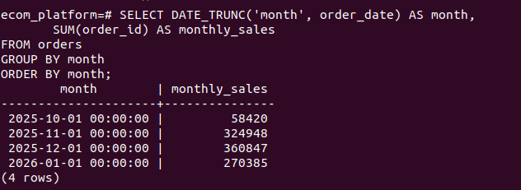

Explanation:
- This query groups sales by month to analyze monthly revenue trends over time.
- It helps businesses track growth patterns, seasonal demand, and forecasting future sales.

roducts Never Sold (Inventory Optimization)

- SELECT p.product_id, p.product_name FROM products p LEFT JOIN order_items oi ON p.product_id = oi.product_id WHERE oi.product_id IS NULL;
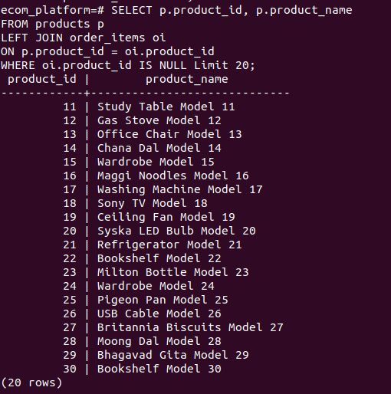

Explanation:
- This query identifies products that have never been purchased.
It helps optimize inventory management, discount planning, and removing slow-moving stock.

Repeat Customers (Customer Retention KPI)
- SELECT user_id, COUNT(order_id) AS total_orders FROM orders GROUP BY user_id HAVING COUNT(order_id) > 2;
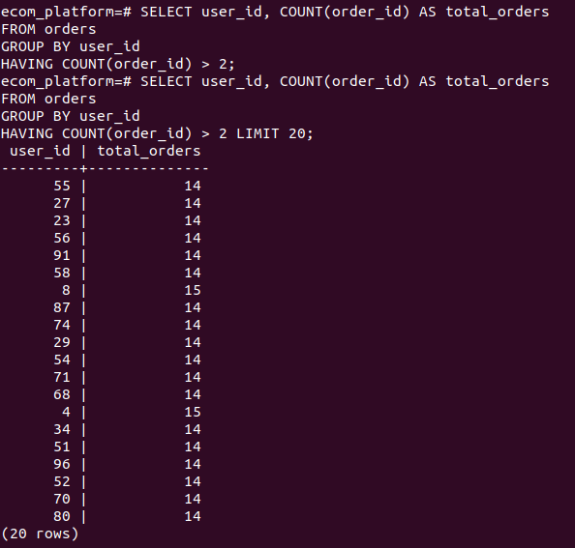

Explanation:
- This query finds customers who placed more than two orders, indicating repeat buyers.

Order Value Classification (Business Segmentation)
- SELECT order_id, total_amount,CASE WHEN total_amount < 5000 THEN 'Low Value'WHEN total_amount BETWEEN 5000 AND 20000 THEN 'Medium Value'ELSE 'High Value'END AS order_category FROM orders;
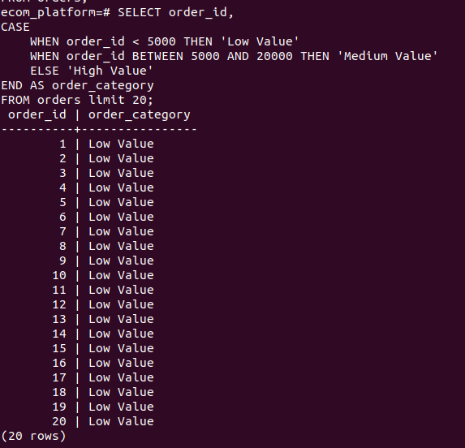

Explanation:
- This query calculates a running cumulative total of sales over time using a window function.

Running Total Sales (Cumulative Revenue Tracking)
- SELECT order_date, total_amount, SUM(total_amount) OVER (ORDER BY order_date) AS running_sales FROM orders;

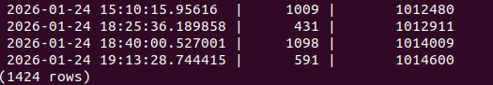
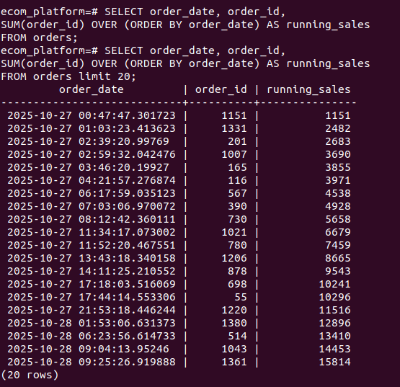

Explanation:
- This query calculates a running cumulative total of sales over time using a window function.
- It is used to monitor business growth, revenue progression, and financial performance trends.

Best-Selling Products by Quantity
- SELECT product_id, SUM(quantity) AS total_units_sold FROM order_items GROUP BY product_id ORDER BY total_units_sold DESC;
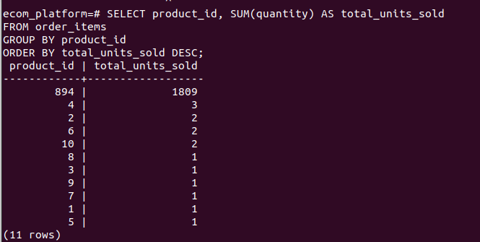

Explanation:
- This query finds products sold in the highest quantity.
- It helps determine demand trends, stock planning, and popular product selection.

Average Order Value (AOV KPI)
- SELECT AVG(order_id) AS avg_order_value FROM orders;
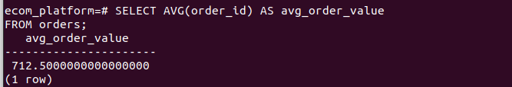

Explanation:
- This query calculates the Average Order Value, a key performance indicator in e-commerce.

Product Revenue Contribution (% Share)

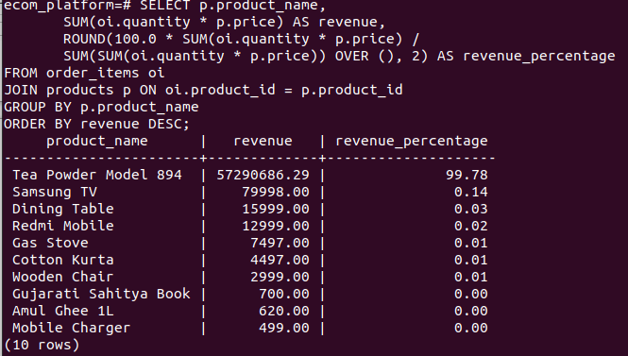
- SELECT p.product_name, SUM(oi.quantity * oi.price) AS revenue,ROUND(100.0 * SUM(oi.quantity * oi.price) / SUM(SUM(oi.quantity * oi.price)) OVER (), 2) AS revenue_percentage FROM order_items oi JOIN products p ON oi.product_id = p.product_idGROUP BY p.product_name ORDER BY revenue DESC;

Explanation:
- This query calculates each product’s percentage contribution to total revenue.
- It helps identify key revenue drivers and prioritize profitable products

Peak Sales Day (Business Performance Insight)
- SELECT order_date, SUM(total_amount) AS daily_sales FROM orders
GROUP BY order_dateORDER BY daily_sales DESC LIMIT 1;
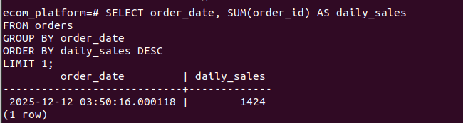

8. ER Diagram

The ER Diagram was generated using DBeaver DBUA, showing:
- Users connected to Orders
- Orders connected to Order Items
- Products linked to Order Items
- Payments linked to Orders
This diagram represents the database schema.

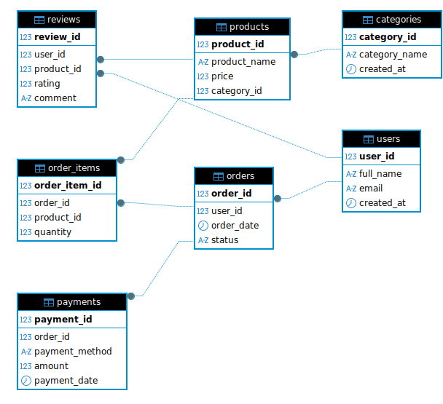

NoSQL Integration for Unstructured Tracking Data
(Hybrid SQL + NoSQL Implementation)
Made By: Jadeja Mouryrajsinh

Introduction
- Traditional SQL databases are best suited for structured data such as users, products, orders, and payments. However, modern e-commerce platforms also generate large volumes of unstructured tracking data such as user clicks, browsing behavior, page visits, and activity logs. To efficiently store and analyze this flexible and fast-growing data, a NoSQL database (MongoDB) was integrated alongside PostgreSQL.

SQL vs NoSQL Role in the System
PostgreSQL (SQL) | MongoDB (NoSQL)
Stores users, products, orders | Stores user activity and tracking logs
Structured relational tables | Flexible JSON documents
Fixed schema | Schema-less design
Transactional data | Event-based behavioral data

NoSQL Database Design

Database Name
Query:-ecommerce_tracking

Collection Name
Query:-user_activity

Business Analytics Using MongoDB

Most Viewed Products
- db.user_activity.aggregate([
{ $match: { event_type: "product_view" } },
{ $group: { _id: "$product_id", total_views: { $sum: 1 } } },
{ $sort: { total_views: -1 } }])

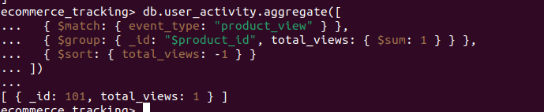
Explanation: Identifies top-viewed products to improve marketing and sales strategies.

Most Active Users
- db.user_activity.aggregate([
{ $group: { _id: "$user_id", activity_count: { $sum: 1 } } },
{ $sort: { activity_count: -1 } } ])
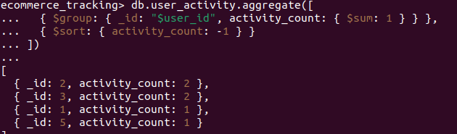
Explanation: Finds highly engaged users for loyalty programs and retention campaigns.

Daily Activity Trend
db.user_activity.aggregate([
{ $group: {
_id: { $dateToString: { format: "%Y-%m-%d", date: "$timestamp" } },
events: { $sum: 1 } } },
{ $sort: { _id: 1 } }
])
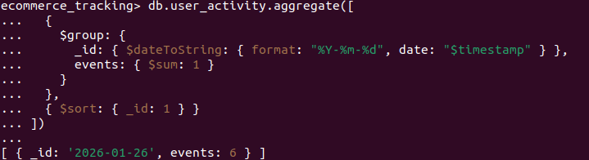
Explanation: Tracks daily growth in user activity and engagement patterns.

Device Usage Analytics
db.user_activity.aggregate([
{ $group: { _id: "$device", count: { $sum: 1 } } }
])
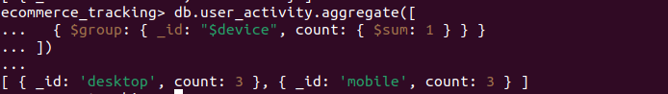
Explanation: Shows mobile vs desktop usage to optimize UI and platform design.

Conversion Funnel Analysis
db.user_activity.aggregate([
{ $match: { event_type: { $in: ["product_view", "add_to_cart", "purchase"] } } },
{ $group: { _id: "$event_type", count: { $sum: 1 } } } ])

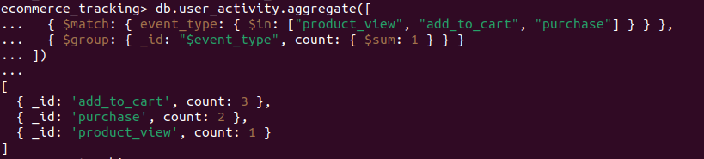
Explanation: Analyzes user journey from viewing products to completing purchases.

Integration Logic Between SQL and NoSQL
- PostgreSQL stores transactional data (users, orders, payments)
- MongoDB stores behavioral tracking data (views, clicks, activity logs)
- user_id and product_id act as shared keys between both systems
- This enables combined analytics, such as identifying users who browse frequently and purchase often

Real-World Use Case Example
Action | Stored In
User places an order | PostgreSQL
User views a product | MongoDB
User searches products | MongoDB
User payment | PostgreSQL

Conclusion: SQL and NoSQL Integration

This project successfully demonstrates the use of SQL (PostgreSQL) for structured transactional data such as users, products, orders, and payments, ensuring strong data integrity and relational consistency. At the same time, NoSQL (MongoDB) was integrated to handle unstructured tracking data such as user activity, browsing behavior, and event logs, providing flexibility and scalability.

